The primal IP problem is:
$$\begin{matrix}max & z=4x_{1}-{ x}_{2} \\ s.t. & 7x_{1}-2x_{2}≤14 \\ & x_{2}≤3 \\ & {2x}_{1}-2x_{2}≤3 \\ & x_{1}, x_{2}≥0, integer\end{matrix}$$
Step 1:
So first, we release the integer constraints. The LP relaxation (Root) is:
$$\begin{matrix}max & z=4x_{1}-{ x}_{2} \\ s.t. & 7x_{1}-2x_{2}≤14 \\ & x_{2}≤3 \\ & {2x}_{1}-2x_{2}≤3 \\ & x_{1}, { x}_{2}≥0\end{matrix}$$
The optimal solution for this problem (Root) is:
$$\begin{matrix}x_{1}=\frac{20}{7} \\ x_{2}=3\end{matrix}$$
With $z^{LP,*}=\frac{59}{7}$
So we have an Upper Bound $8$.
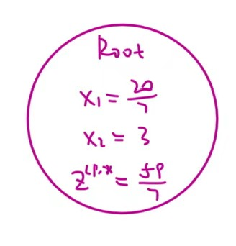
Step 2:
In the following steps, I will use Deep First Search.
Noticing that $x_{1}$ is fractional, so we branch on $x_{1}$.
We choose to add $x_{1}≤2$ to get a new problem S1:
$$\begin{matrix}max & z=4x_{1}-{ x}_{2} \\ s.t. & 7x_{1}-2x_{2}≤14 \\ & x_{2}≤3 \\ & {2x}_{1}-2x_{2}≤3 \\ & x_{1} ≤2 \\ & x_{1}, { x}_{2}≥0\end{matrix}$$
The optimal solution for this problem (S1) is:
$$\begin{matrix}x_{1}=2 \\ x_{2}=0.5\end{matrix}$$
With $z^{LP,x_{1}≤2}=7.5$
The Upper Bound is still $8$.
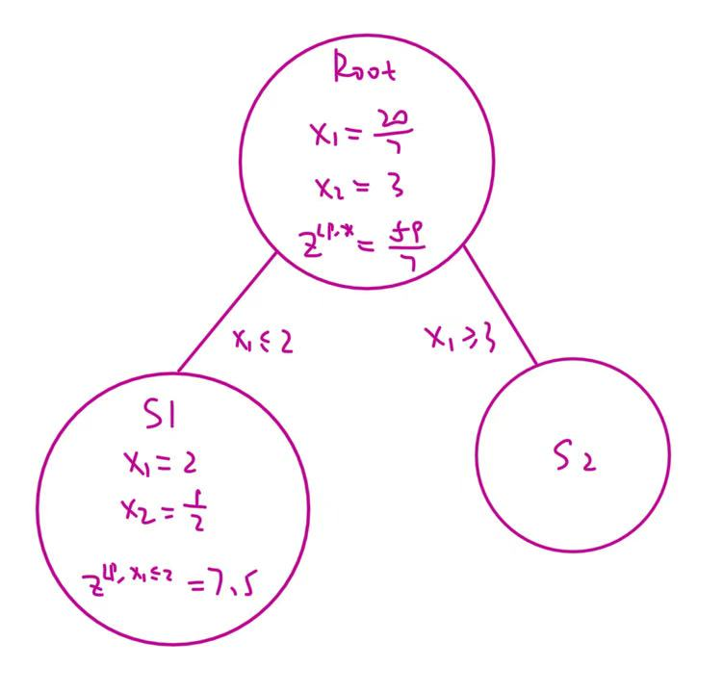
Step 3:
Noticing that $x_{2}$ is fractional, so we branch on $x_{2}$.
We choose to add $x_{2}≤0$ to get a new problem S3:
$$\begin{matrix}max & z=4x_{1}-{ x}_{2} \\ s.t. & 7x_{1}-2x_{2}≤14 \\ & x_{2}≤3 \\ & {2x}_{1}-2x_{2}≤3 \\ & x_{1} ≤2 \\ & x_{2}≤0 \\ & x_{1}, { x}_{2}≥0\end{matrix}$$
The optimal solution for this problem (S3) is:
$$\begin{matrix}x_{1}=1.5 \\ x_{2}=0\end{matrix}$$
With $z^{LP,x_{1}≤2,x_{2}≤0}=6$
The Upper Bound is still $8$.
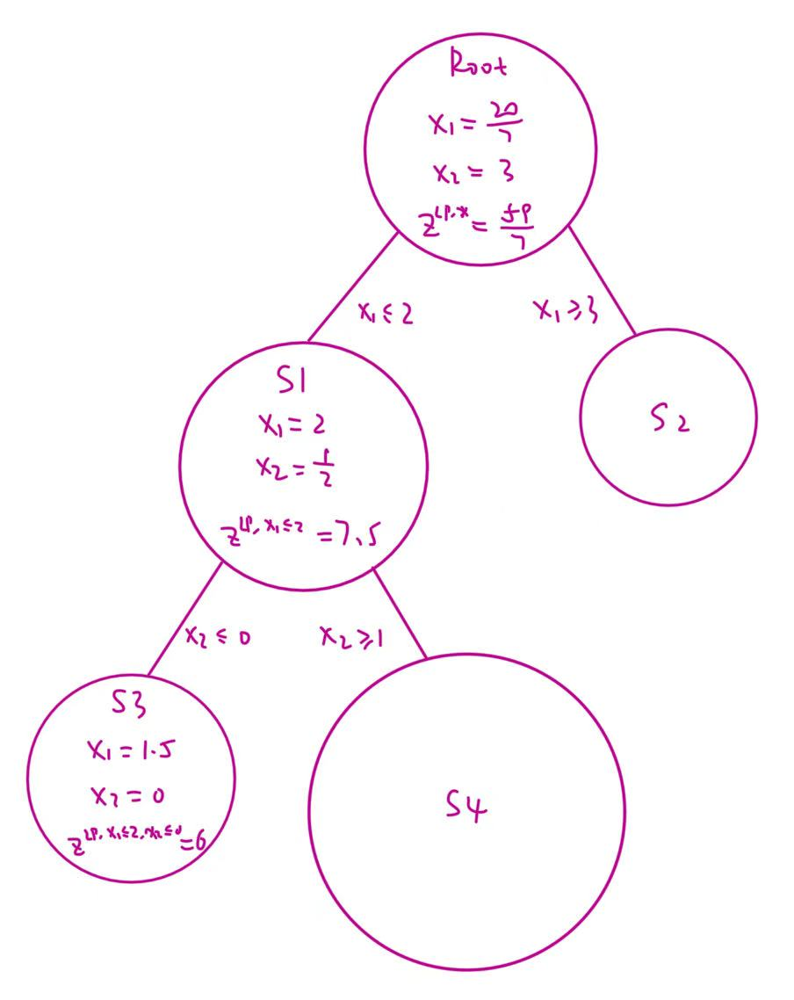
Step 4:
Noticing that $x_{1}$ is fractional, so we branch on $x_{1}$.
We choose to add $x_{1}≤1$ to get a new problem S7:
$$\begin{matrix}max & z=4x_{1}-{ x}_{2} \\ s.t. & 7x_{1}-2x_{2}≤14 \\ & x_{2}≤3 \\ & {2x}_{1}-2x_{2}≤3 \\ & x_{1} ≤2 \\ & x_{2}≤0 \\ & x_{1} ≤1 \\ & x_{1}, { x}_{2}≥0\end{matrix}$$
The optimal solution for this problem (S7) is:
$$\begin{matrix}x_{1}=1 \\ x_{2}=0\end{matrix}$$
With $z^{LP,x_{1}≤2,x_{2}≤0,x_{1}≤1}=4$
This is an incumbent solution, so we mark it as the candidate solution, and now we have a Lower Bound, which is $4$. The Upper Bound is still $8$.
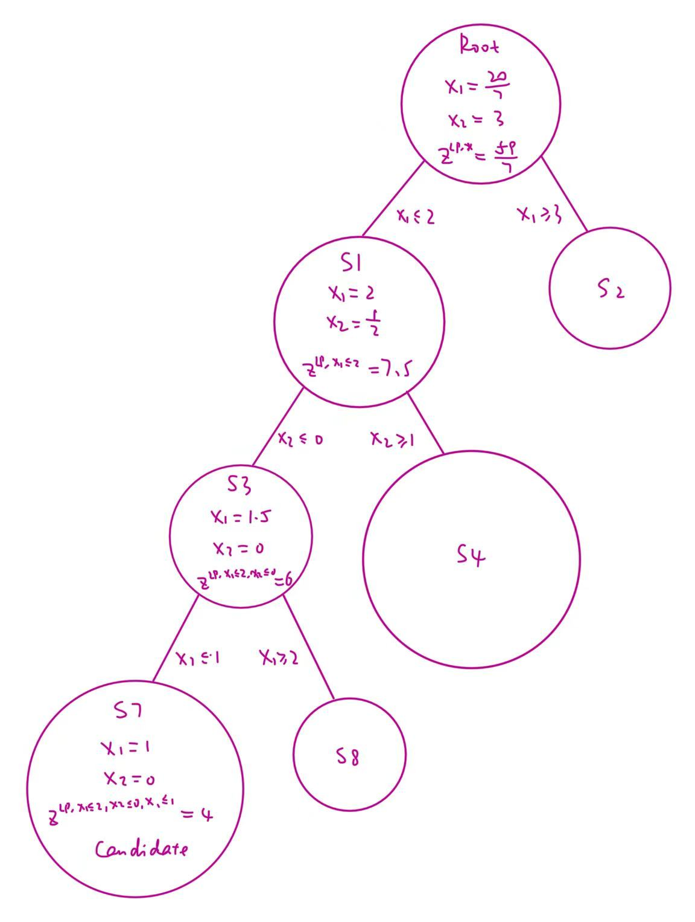
Step 5:
When we add $x_{1}≤1$ in step 4, we also have created another branch with the added constraint $x_{1}≤2$. We mark this new problem as problem S8:
$$\begin{matrix}max & z=4x_{1}-{ x}_{2} \\ s.t. & 7x_{1}-2x_{2}≤14 \\ & x_{2}≤3 \\ & {2x}_{1}-2x_{2}≤3 \\ & x_{1} ≤2 \\ & x_{2}≤0 \\ & x_{1} ≥2 \\ & x_{1}, { x}_{2}≥0\end{matrix}$$
This problem is infeasible. We can prune this branch.
The Lower Bound is still $4$. The Upper Bound is still $8$.
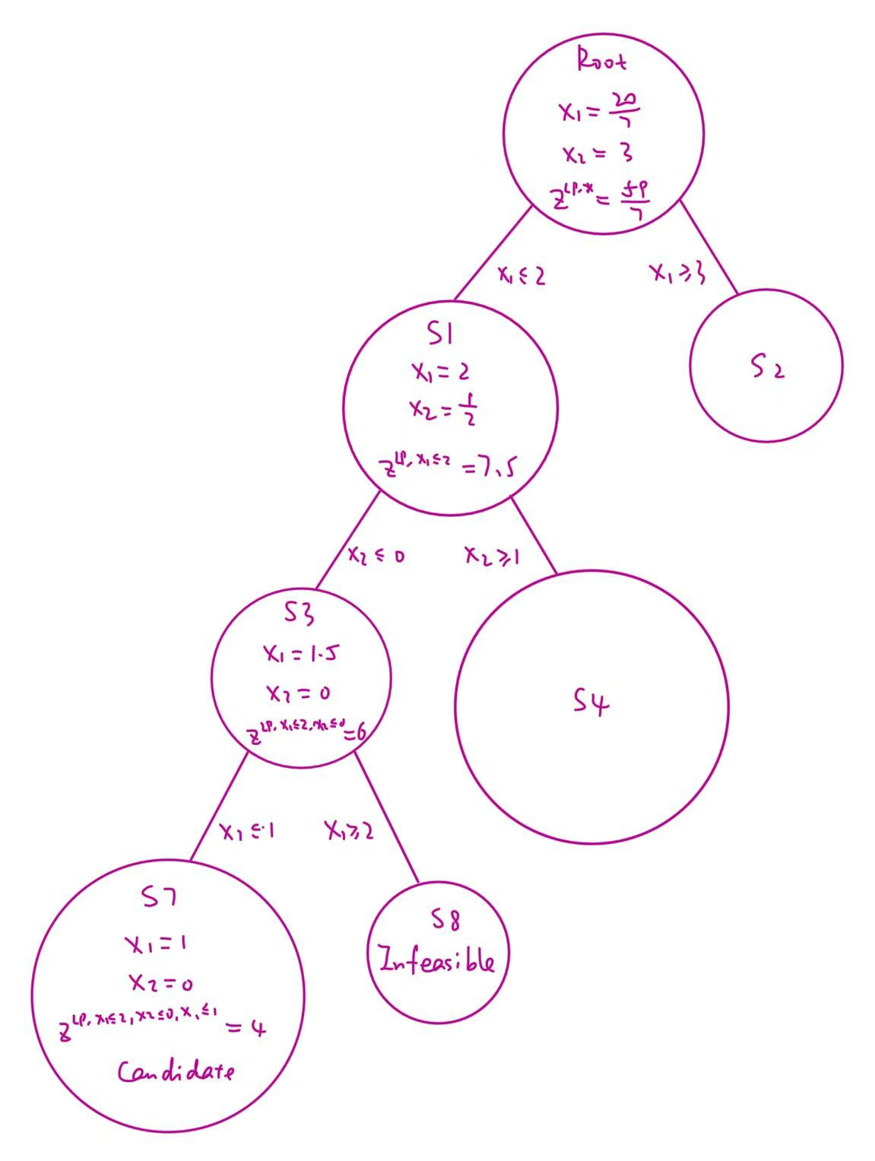
Step 6:
When we add $x_{2}≤0$ in step 3, we also have created another branch with the added constraint $x_{2}≥1$. We mark this new problem as problem S4:
$$\begin{matrix}max & z=4x_{1}-{ x}_{2} \\ s.t. & 7x_{1}-2x_{2}≤14 \\ & x_{2}≤3 \\ & {2x}_{1}-2x_{2}≤3 \\ & x_{1} ≤2 \\ & x_{2}≥1 \\ & x_{1}, { x}_{2}≥0\end{matrix}$$
The optimal solution for this problem (S4) is:
$$\begin{matrix}x_{1}=2 \\ x_{2}=1\end{matrix}$$
With $z^{LP,x_{1}≤2,x_{2}≥1}=7$
This is an incumbent solution and has a better objective function value, so we update the candidate solution to this solution, and now we have a new Lower Bound, which is $7$. The Upper Bound is still $8$.
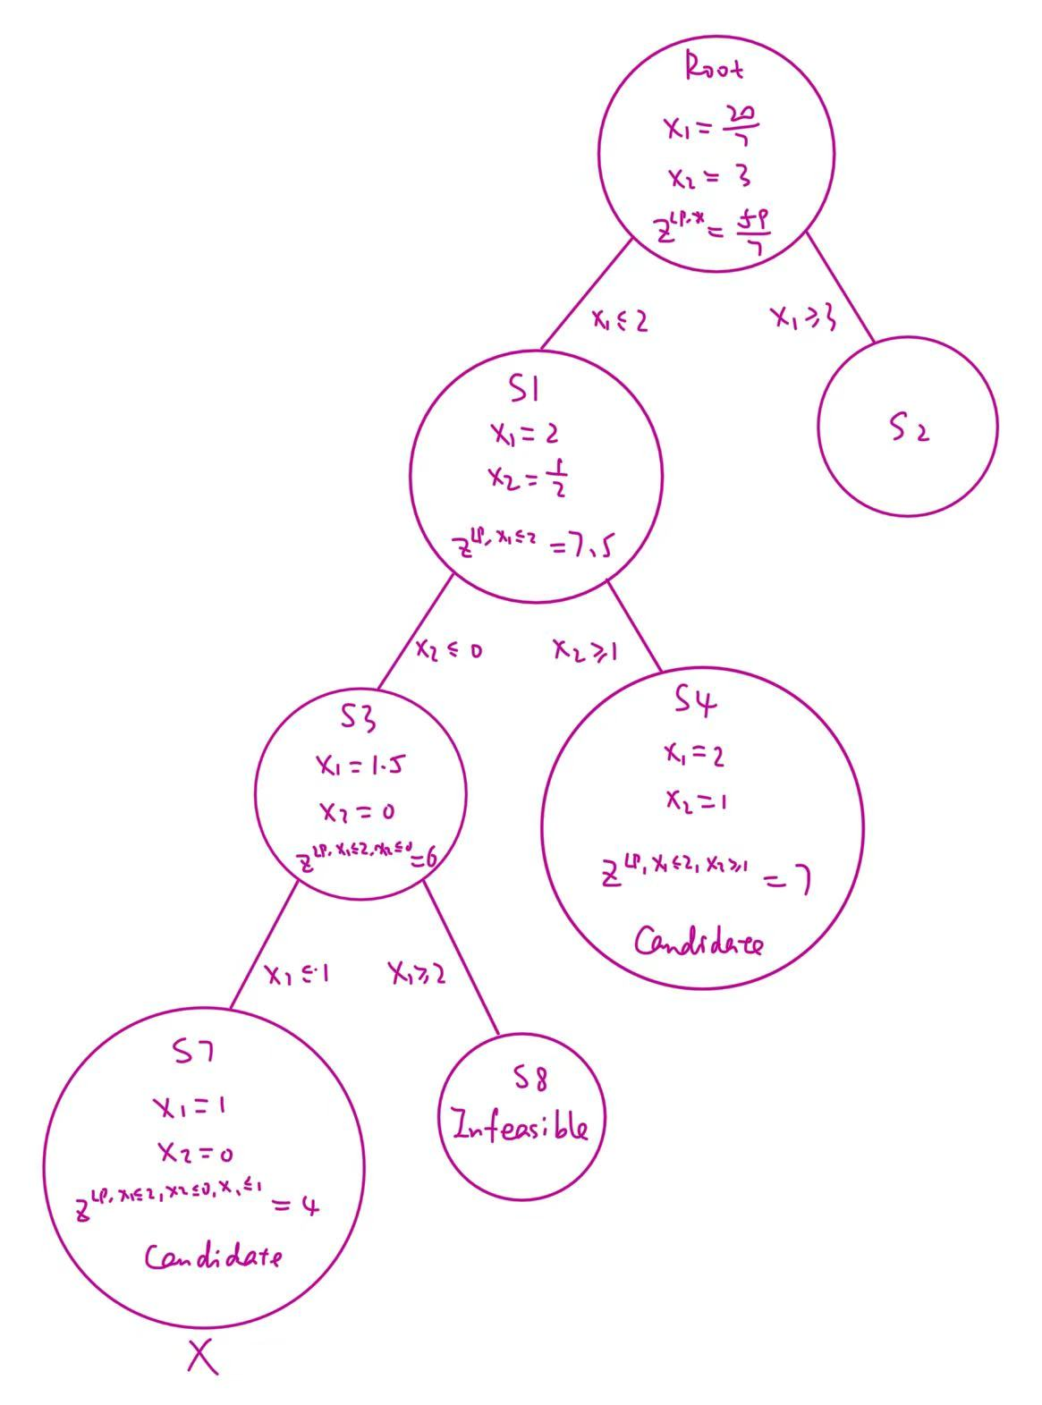
Step 7:
When we add $x_{1}≤2$ in step 2, we also have created another branch with the added constraint $x_{1}≥3$. We mark this new problem as problem S2:
$$\begin{matrix}max & z=4x_{1}-{ x}_{2} \\ s.t. & 7x_{1}-2x_{2}≤14 \\ & x_{2}≤3 \\ & {2x}_{1}-2x_{2}≤3 \\ & x_{1} ≥3 \\ & x_{1}, { x}_{2}≥0\end{matrix}$$
This problem is infeasible. We can prune this branch.
The Lower Bound is still $7$. The Upper Bound is still $8$.
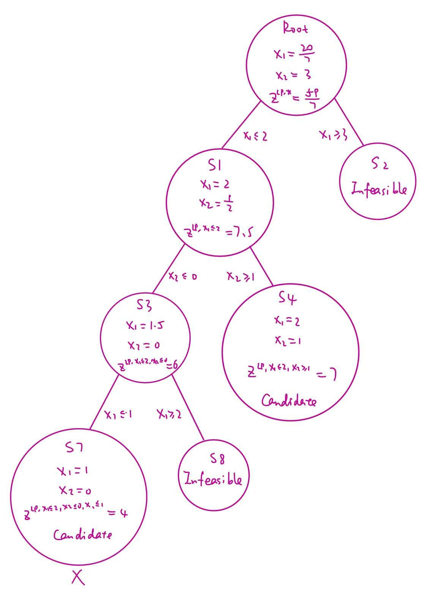
Final Step:
Now, all subproblems on branches are solved.
Use the value in the candidate solution to check all the constraints in the primal problem. All constraints are observed.
So, the candidate solution will be the optimal one.
So we have the optimal solution:
$$\begin{matrix}x_{1}=2 \\ x_{2}=1\end{matrix}$$
And Optimal Objective Function Value $z^{IP,*}=7$
